Reading Diary

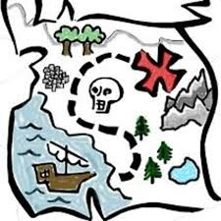
"There is more treasure in books than in all the pirate's loot on Treasure Island." -Walt Disney

NAME AND SURNAME: ________________________________________

COURSE:____________________________________________________

“These books gave Matilda a hopeful and comforting message: You are not alone.” – Roald Dahl

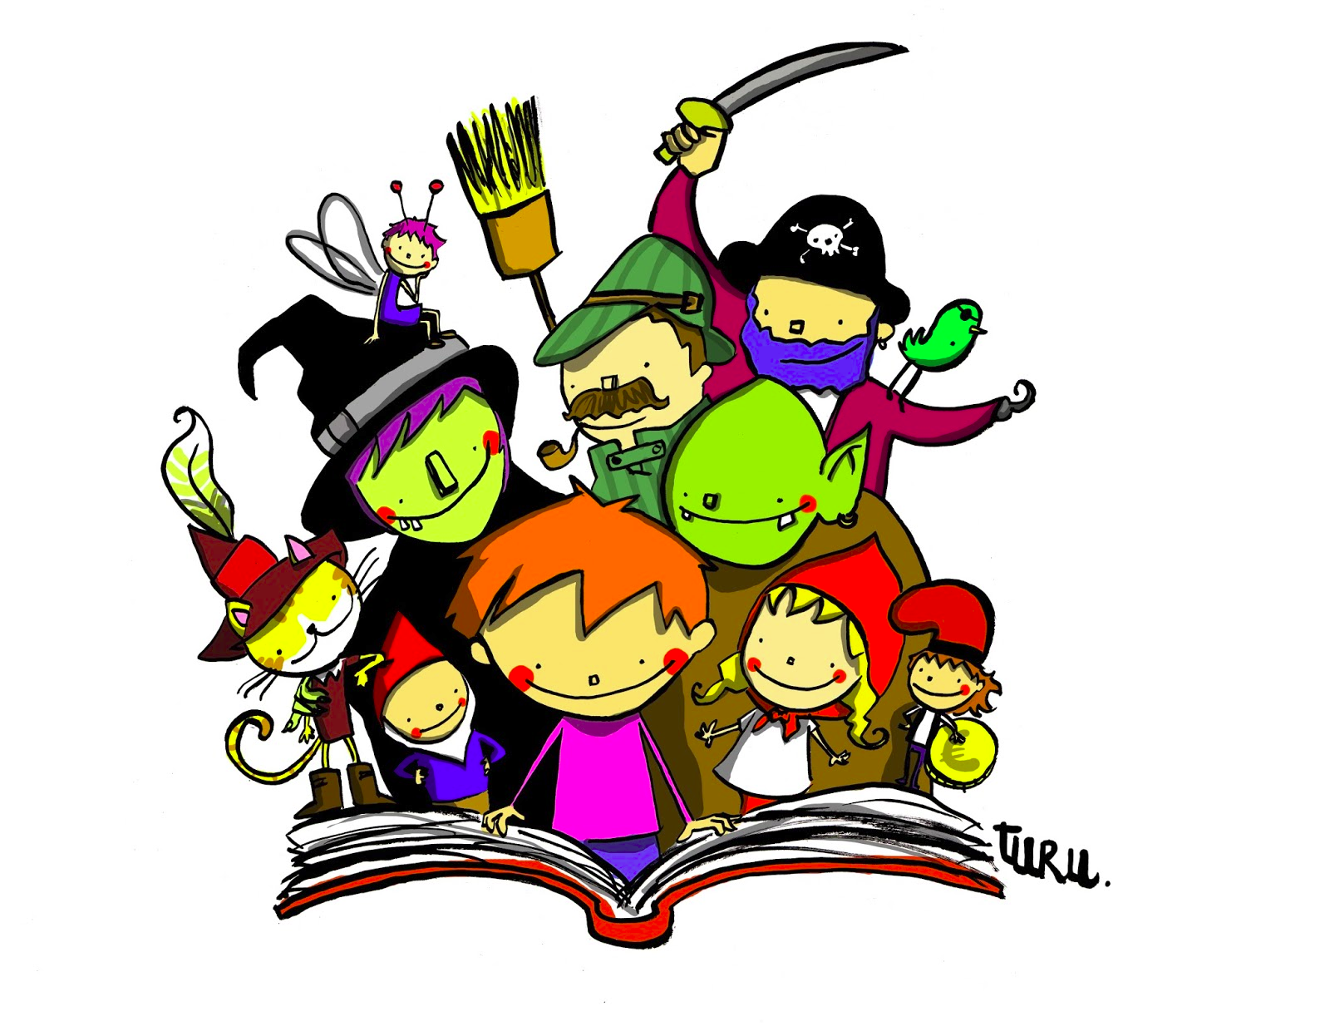
ENGLISH DEPARTMENT
INSTITUT PUIG CASTELLAR BOOK REVIEW
TITTLE:

AUTHOR:

FICTION NON-FICTION

RATING:

Before reading this book I imagine the book tells a story about..…

I start reading the book on...

Meanwhile I was reading the book I have found some difficult or surprising words. I have checked their meaning in a dictionary and these are the words and their meanings:

I have finished reading the book on...

After reading the book, I have known that the plot is about …

This is my opinion about the book: I would/wouldn’t recommend the book

The book has inspired me the following picture

